UNDERTAKING TO MAINTAIN CONFIDENTIALITY

I Ayush Kumar Singh s/o/w/o/d/o Abhay Prakash Singh r/o 504A,Ashiana Green City, Danapur, Patna, Bihar-801503 enrolled as an Intern in the Data Quality and Governanceteam under the Nesternship Program with Nestle India Limited, a company incorporated under the Companies Act, 1956 having its registered office at 100 / 101, World Trade Cere, Barakhamba Lane, New Delhi – 110001 (“Company”) do hereby state and undertake as follows:

- I have been shortlisted by the Company to join as an intern for the period 22nd April’25 to 22nd 22nd July’25 under its Nesternship Internship Program ("Internship Program"), to work under a dedicated mentor on an assigned project.

2. That during the course of my Internship Program in order to enable me to perform, execute and discharge my obligations in terms of the Internship Program, I will acquire and be privy to Company’s Confidential Information in relation to the An automated system for detecting data anomalies in spreadsheets, improving data quality and reliability (“Project”).

("Confidential Information" means any and all the information or data, regardless of whether it is in tangible form or not, communicated orally or in writing, by electronic or magnetic media, by visual observation or by other means, of the Company that is not generally available to the public. The Confidential Information shall include, without limitation, information regarding technical knowhow, designs, drawings, manufacturing and assembly processes and procedures, equipment, business plans, strategies, technology, current and potential customers, current and potential business partners, employee lists and other business information and the Company’s products, discoveries, inventions, research, techniques, software and other proprietary information and whether that is identified, marked & stamped as confidential or not).

3. I confirm that I shall return to the Company any and all items containing or consisting of Confidential Information and all copies (including electronic form).

4. I hereby acknowledge and undertake that the Confidential Information, is the sole property of the Company and that I shall hold the Confidential Information in strict confidence not to disclose such Confidential Information to any person not involved with the project and who has not signed a similar undertaking, and/or any third parties, directly or indirectly.

5. I fully understand and confirm that the obligations set out herein shall extend until such time the Confidential Information becomes publicly available or I have been specifically discharged of my obligations hereunder by the Company.

6. I hereby acknowledge that any unauthorized disclosure or use of such Confidential Information would cause irreparable harm and significant injury, the degree of which may be difficult to ascertain and the Company has the right to obtain an immediate injunction enjoining any breach of this Affidavit cum Undertaking, as well as the right to pursue any and all other rights and remedies available at law or in equity for such a breach.

I Ayush Kumar Singh have set my hands to this Undertaking at the place and on the date in the presence of the witnesses.

Signed for and behalf of:
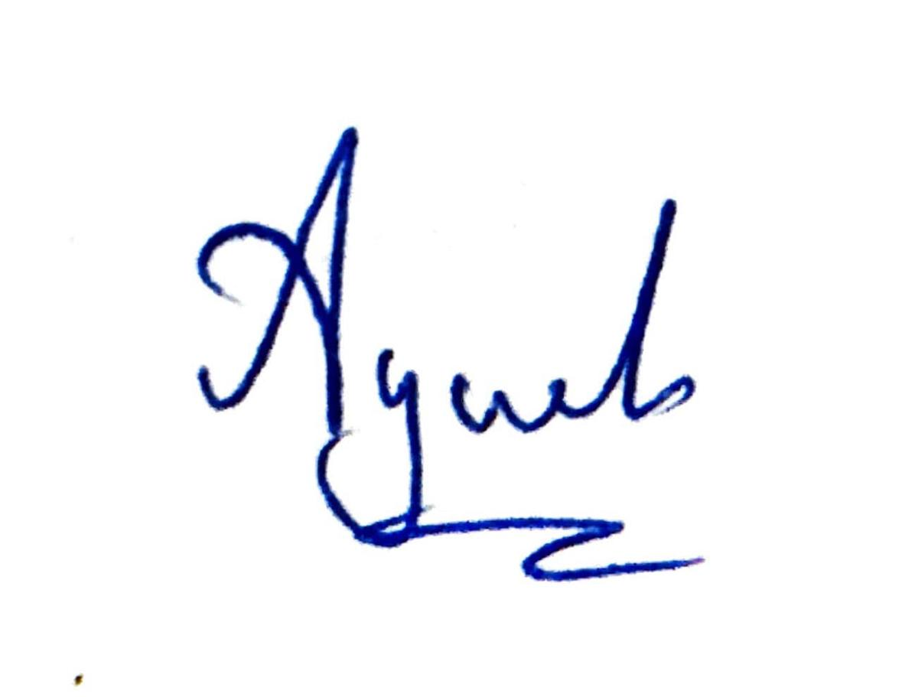
Date:22/04/2025
Place:Ghaziabad

In the presence of Harsh

